FIRST LOG INTO LITEBLUE USING YOUR EIN AND POSTALEASE PASSWORD

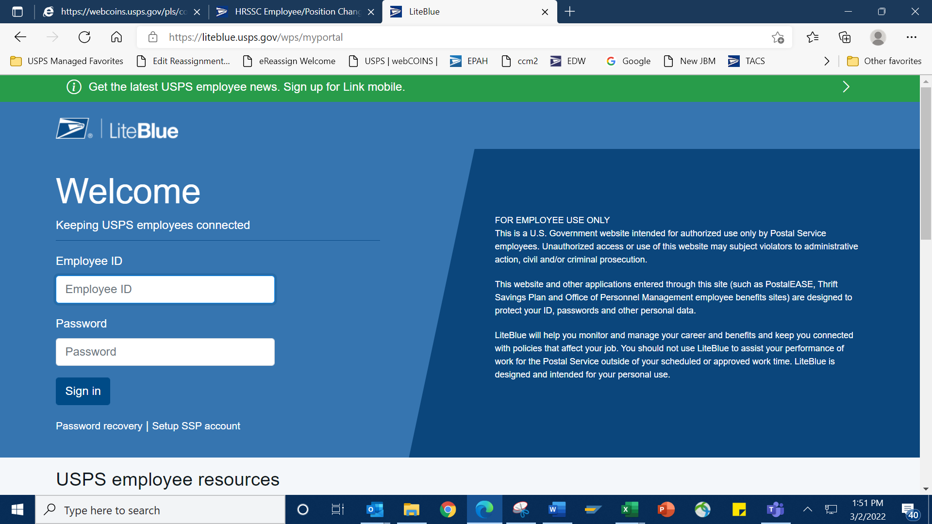

ONCE LOGGED IN, SCROLL DOWN TO EMPLOYEE APPS AND CLICK ON EREASSIGN

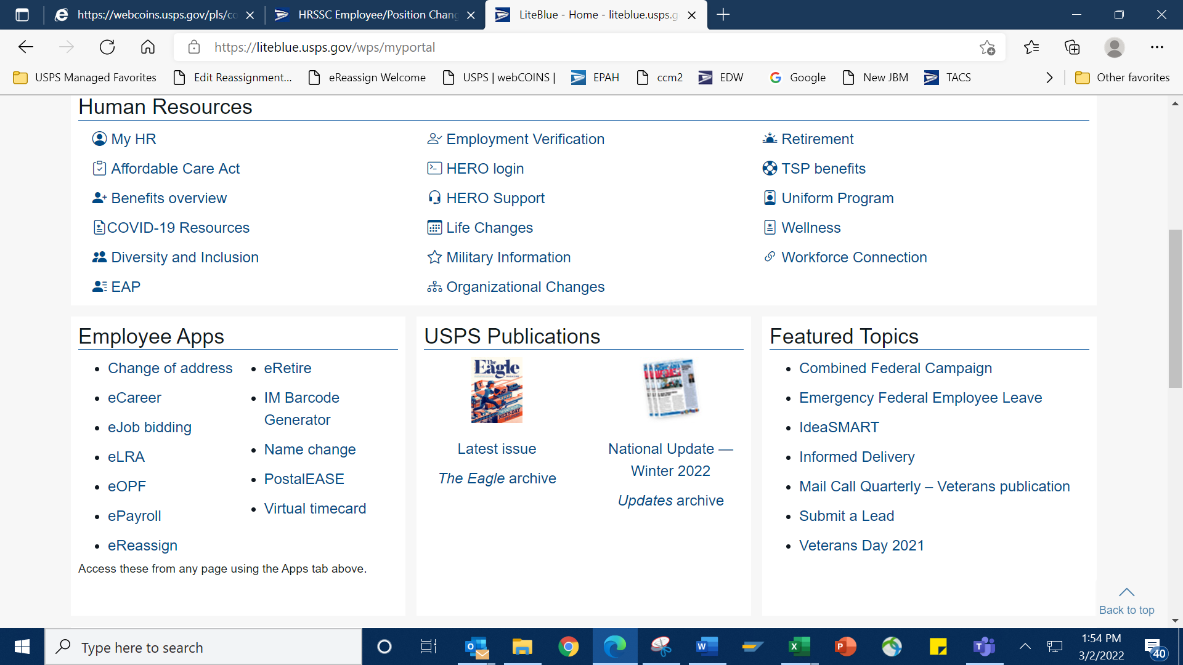

THEN LOG INTO EREASSIGN USING YOUR EIN AND POSTALEASE PASSWORD

FROM THE WELCOME PAGE, YOU CAN SEARCH BY STATE, CITY OR REASSIGNMENT OPPORTUNITIES POSTED THEN SUBMIT A REQUEST

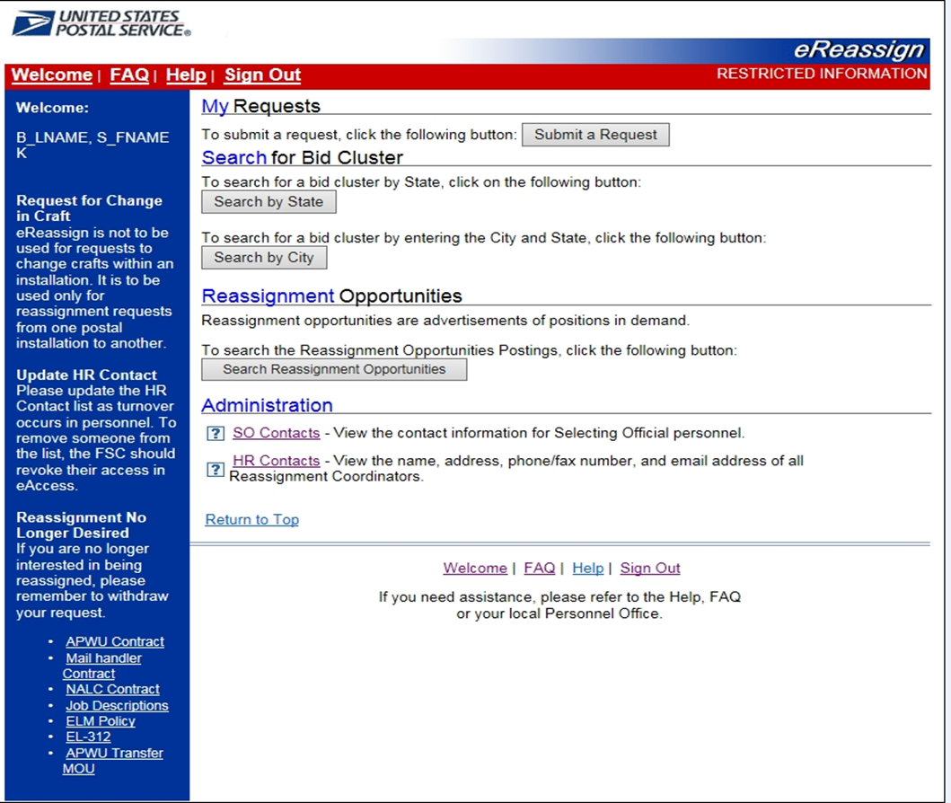
COMPLETE THE REQUIRED INFORMATION

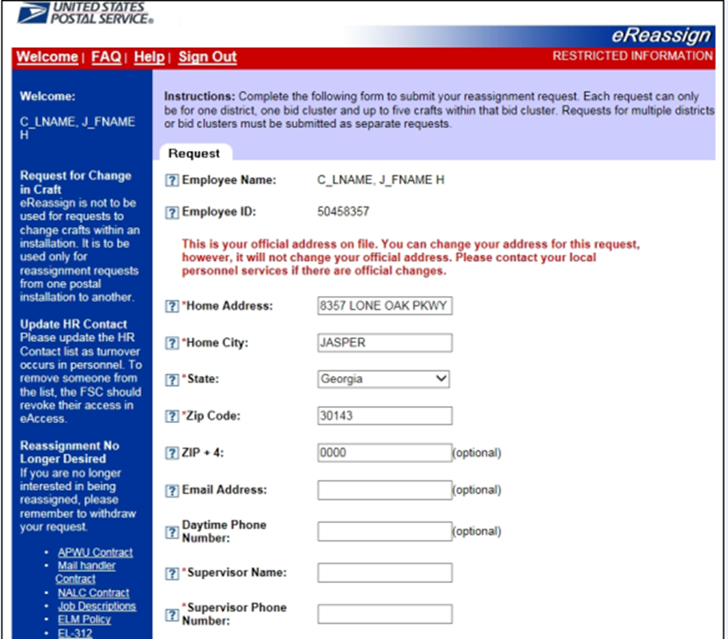

AND THEN SUBMIT

